|  |  |
| --- | --- |
| **Name:** | **Dhuware Chaitanya Rakesh** |
| **Roll Number:** | **20IM10009** |

**1.Aim of the experiment:**

**2.Tools used:**

* **VS Labs**
* **Falstad**

**3.Background knowledge (brief):**

* A **voltage divider** is a simple circuit which turns a large voltage into a smaller one. Using just two series resistors and an input voltage, we can create an output voltage that is a fraction of the input. A voltage divider involves applying a voltage source across a series of two resistors.
* For a voltage divider: Vout = Vin(R2/R1+R2).
* In Thevenin’s equivalent circuit of the voltage divider, the voltage source is replaced by an equivalent Thevenin’s voltage and all the resistors are replaced by a single equivalent Thevenin’s resistance.

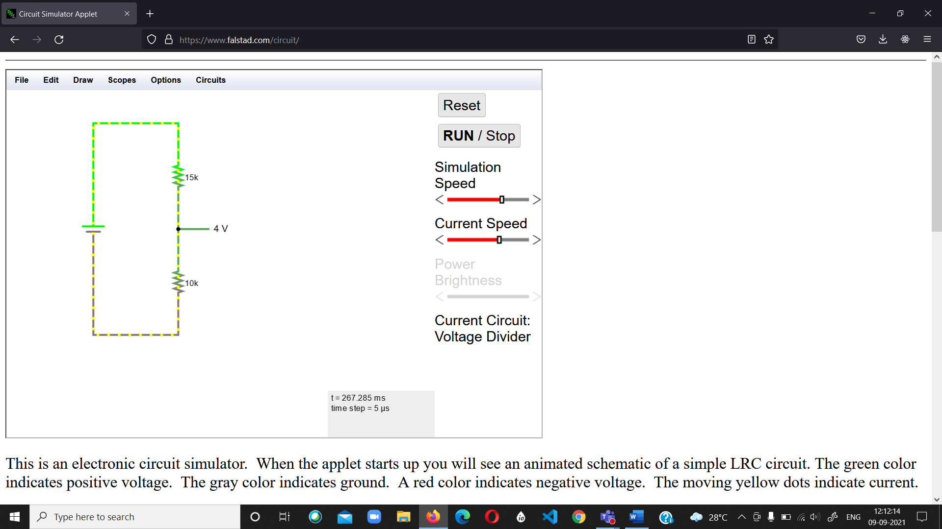**4.Circuit (hand drawn/image)**

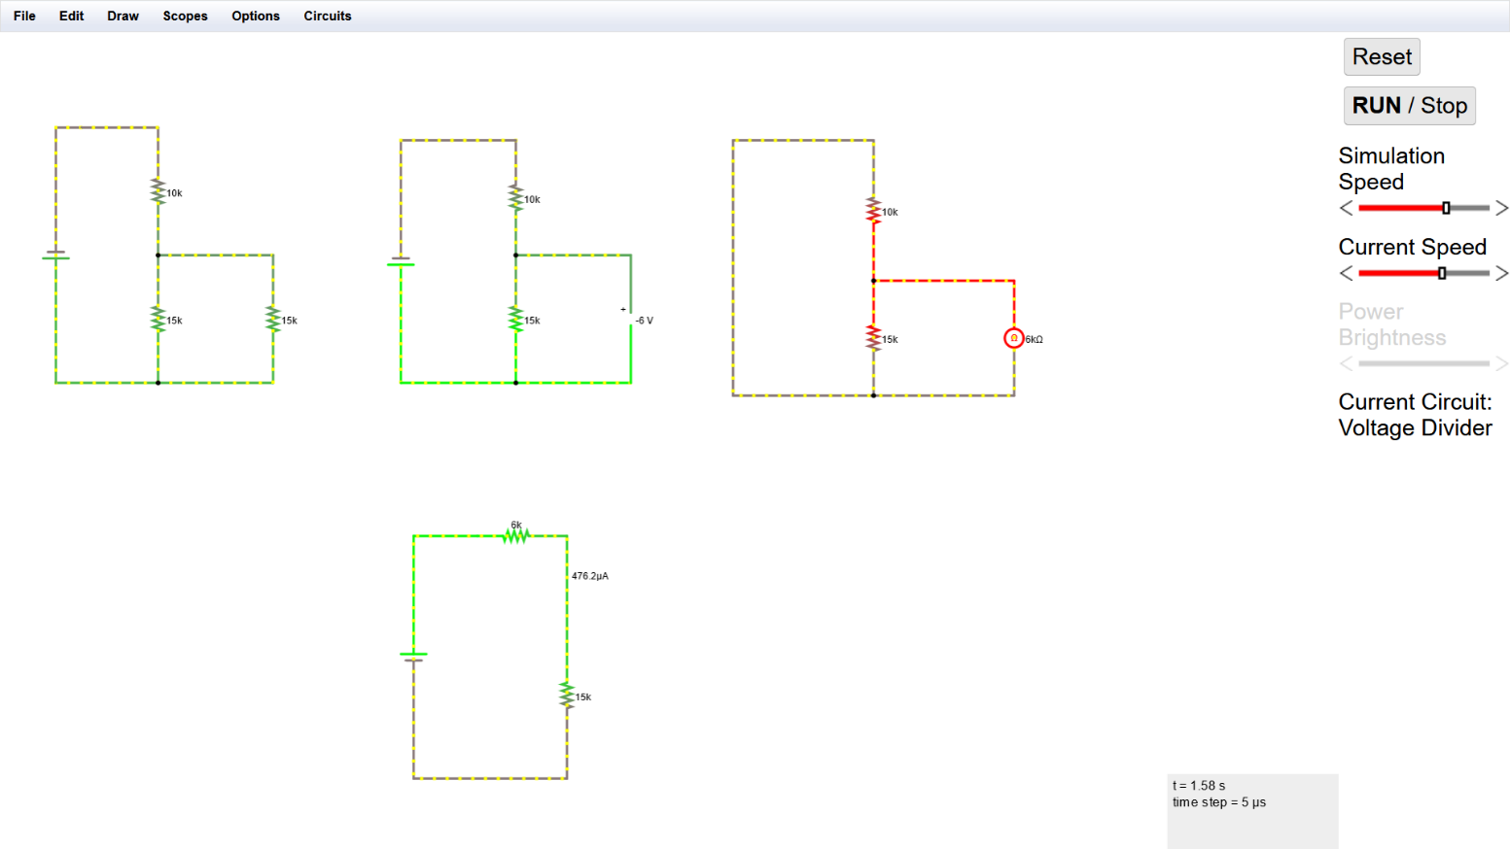

**5.Measurement Data (Tabular form)**

**6.Graph (Image)/Screenshots**

**7.Conclusion**

**8.Discussions**